ABSTRACT #
Automatic Kidney Detection and Segmentation from 3D Ultrasound Image Using Graph Searching and Level Set
Li Xin¹, Matthias Noll¹, Stefan Wesarg¹
¹ Cognitive Computing & Medical Imaging, Fraunhofer IGD, Darmstadt, Germany

Introduction: Ultrasound is the preferred imaging modality for kidney disease diagnosis because it is real-time and low cost. Although ultrasonography is said to be the safest medical imaging technique, its speckle noise and poor signal-to-noise ratio poses a big challenge for designing automated detection and segmentation algorithms. The aim of this study is to design an automated method for detection and segmentation of the kidney in 3D ultrasound images, utilizing both image signal information and shape priors for graph searching and the Level Set algorithm.

Methods: We designed four major steps in order to localize and segment the kidney. In the first step the ultrasound is smoothed and downscaled using a multi-scale image pyramid. Additionally, we enhance the image contrast through histogram equalization. Secondly, Otsu's method is used to generate a threshold image that contains several kidney shape “candidates”. To find the kidney position among the potential kidney candidates, a graph based searching algorithm traverses the image with two step sizes equal to the two major kidney axes derived from a kidney shape model. For each graph node we then send 12 rays along the default image axes with a maximum travel distance matching the kidney shape size. We then detect the first zero-to-one crossing along each ray. The graph node with the highest count of zero-to-one crossings is selected as the kidney position. In the final step, seed points are placed with an offset d along the ray direction. Using all seed points the fast marching algorithm generates a coarse kidney shape from the preprocessed ultrasound image. The fast marching result, in turn is utilized to initialize the level set algorithm which then produces the final and accurate kidney segmentation.

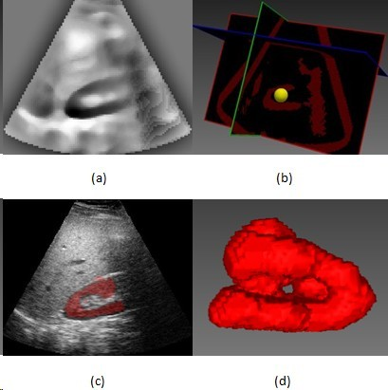
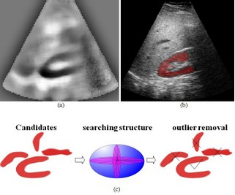
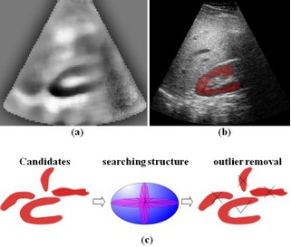
Results: Experiments were carried out for 62 three-dimensional ultrasound images of 8 healthy male and female volunteers. Figure (a) shows the contrast-enhanced ultrasound input. In figure (b) the segmentation result of the proposed approach on the automatically detected kidney candidate is shown. The graph based searching procedure on the threshold image is illustrated in figure (c). The proposed method was successfully applied in over 90% of the available test cases. In only 6 cases a kidney candidate could not be determined due to strong image artifacts such as acoustic rib shadows.

Conclusion: A method for automatic kidney segmentation in 3D ultrasound has been proposed. Both image signal information and object shape priors are used in the detection and segmentation process. Based on the segmentation result further diagnosis can be achieved.

Figure. (a) Enhanced image (b) Segmentation result
(c) Graph searching for kidney shape

